Lecture # 25:

Objective:

* REGULAR EXPRESSON

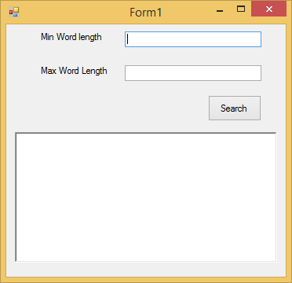

using System;

using System.Collections.Generic; using System.ComponentModel; using System.Data;

using System.Drawing; using System.Linq; using System.Text;

using System.Windows.Forms;

using System.Text.RegularExpressions;

namespace regexsrching

{

public partial class Form1 : Form

{

public Form1()

{

InitializeComponent();

}

private void Form1_Load(object sender, EventArgs e)

{

}

private void btnsearch_Click(object sender, EventArgs e)

{

MatchCollection mm = Regex.Matches(richTextBox1.Text, @"\b\w{"+textmin.Text+","+textmax.Text+"}\b");

foreach (Match item in mm)

{

MessageBox.Show(item.Value);

}

}

}

}